**Radiophony Screenshots (Projet Streaming Radio)**

**Khouni Balkis Nfaiedh Mariem Selmi Meriem**

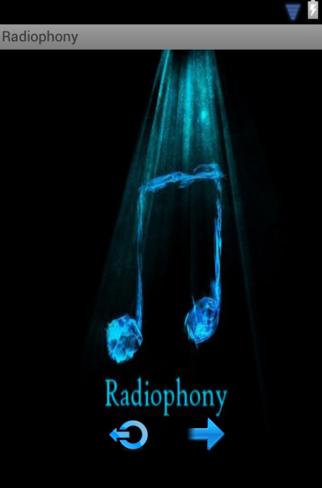

|  |  |  |  |
| --- | --- | --- | --- |
| C:\Users\Meriem\Desktop\Snapshots\1-Splash Screen.png | 1. Splash Screen |  | 1. Hello View   You can get in, or quit |
| C:\Users\Meriem\Desktop\Snapshots\3-RadioList.png | 1. List View | C:\Users\Meriem\Desktop\Snapshots\4-Playing Radio.png | 1. Playing Radio |
| C:\Users\Meriem\Desktop\Snapshots\5-LongTap Set Favorite.png | 1. Long Tap on a Fun Radio to set it as Favorite | C:\Users\Meriem\Desktop\Snapshots\6-Fun Radio is Favorite (displays on top of list).png | 1. When launching the app again (after destroying it) Fun Radio appears on top   (if mis already set as Favorite) |
| C:\Users\Meriem\Desktop\Snapshots\7-Notification when Radio is on.png | 1. When a radio channe lis playing, if we stop the app, a notification shows up | C:\Users\Meriem\Desktop\Snapshots\8-Notification when Radio is on.png | 1. We can go back to the app by selecting the notification |

**PS :**

**We made use of i18n (fr and english), and sqlite.**